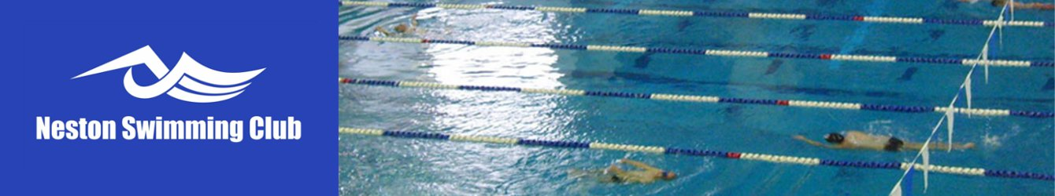

NOMINATION FORM
FOR CONSIDERATION AT THE
ANNUAL GENERAL MEETING

Wednesday 20th November 2019 at 7.45pm
Community Room, Neston Recreation Centre

NAME:
POSITION (applied for)
SIGNATURE

PROPOSED BY:
SIGNATURE

SECONDED BY:
SIGNATURE

Nominees must be members of the Club.

Nomination forms duly completed and in a sealed envelope to be sent to the Secretary:

Mike Schofield,
Secretary – Neston Swimming Club,
C/O Neston Recreation Centre,
Raby Park Road,
Neston,
CH64 9NQ.

Or by email to nestonswim@gmail.com

To arrive no later than Midnight on Wednesday 30th October 2019

